 | 7.3.8 Editors - 3D Viewport - Sidebar - Tool Tab - Texture Paint Mode
Table of content
Detailed table of content 2
Tools Tab in Texture Paint Mode 7
Requirements 7
Save Texture 7
Brush Asset Panel 8
Browse Brush 8
Brush Specials menu 8
Brush settings Panel 9
Brush Panel 9
Brush Settings Panel - Color Picker Sub panel 10
Brush colors flip 11
Use unified Color 11
Brush Settings Panel - Color Palette Sub panel 11
Palette browser 11
Edit Box 11
Number of users 11
Fake User 12
Add palette 12
Remove Palette 12
Sort By 12
Brush Settings Panel - Advanced Subpanel 12
Brush Type 12
Accumulate 12
Affect Alpha 12
Randomize Color – Subpanel 12
Mode – Subpanel 13
Sharpen / Soften (Soften Brush) 13
Blur Mode (Soften Brush) 13
Mask Value (Mask brush) 13
Brush Settings Panel - Texture Subpanel 13
Browse Texture to be linked 14
Brush Mapping 15
Brush Settings Panel - Texture Mask Subanel 19
Browse Texture to be linked 19
Brush Mapping with mapping method Tiled 20
Brush Mapping with mapping method View Plane 21
Brush Settings Panel - Stroke Sub panel 24
Stroke Panel with Stroke method Space 24
Stroke Panel with Stroke method Curve 25
Stroke Panel with Stroke method Line 27
Stroke Panel with Stroke method Anchored 28
Brush Settings Panel - Falloff Sub panel 31
Selecting Points 31
Adding Points 31
Navigation elements 31
Brush Settings Panel - Cursor Sub panel 33
Cursor Checkbox 33
Cursor Color 33
Falloff Opacity 33
Texture Opacity 33
Mask Texture Opacity 34
Brush Settings Panel - Clone from Paint Slot Sub panel 34
Symmetry Panel 34
Symmetry Panel 34
Options Panel 35
Bleed 35
Dither 35
Occlude 35
Backface Culling 35
External 35

Detailed table of content

Detailed table of content
Detailed table of content 2
Tools Tab in Texture Paint Mode 7
Requirements 7
Save Texture 7
Brush Asset Panel 8
Browse Brush 8
Brush Specials menu 8
Edit Metadata 8
Catalog 8
Author 8
Desctription 8
OK / Cancel 8
Edit Preview Image 8
Save Brush Asset 9
Revert Brush Asset 9
Name 9
Brush settings Panel 9
Brush Panel 9
Blend 10
Radius 10
Size Pressure 10
Use Unified Radius 10
Strength 10
Size Pressure 10
Use Unified Radius 10
Brush Settings Panel - Color Picker Sub panel 10
Brush colors flip 11
Use unified Color 11
Brush Settings Panel - Color Palette Sub panel 11
Palette browser 11
Edit Box 11
Number of users 11
Fake User 12
Add palette 12
Remove Palette 12
Sort By 12
Brush Settings Panel - Advanced Subpanel 12
Brush Type 12
Accumulate 12
Affect Alpha 12
Randomize Color – Subpanel 12
Stroke Randomization 12
Use Pressure 12
Hue 13
Saturation 13
Value 13
Mode – Subpanel 13
Sharpen / Soften (Soften Brush) 13
Sharp Threshold 13
Blur Mode (Soften Brush) 13
Mask Value (Mask brush) 13
Brush Settings Panel - Texture Subpanel 13
Browse Texture to be linked 14
Texture Edit box 15
Brush Mapping 15
Brush Mapping with mapping method Tiled 16
Angle 16
Offset 16
Size 16
Brush Mapping with mapping method View Plane 16
Angle 16
Rake 16
Random 16
Offset 16
Size 16
Brush Mapping with mapping method 3D 17
Offset 17
Size 17
Brush Mapping with mapping method Random 17
Angle 17
Rake 17
Random 17
Brush Mapping with mapping method Stencil 17
Image Aspect 18
Reset Transform 18
Angle edit box 18
Offset 18
Size 18
Brush Settings Panel - Texture Mask Subanel 19
Browse Texture to be linked 19
Brush Mapping with mapping method Tiled 20
Pressure Masking 20
Angle 21
Offset 21
Size 21
Brush Mapping with mapping method View Plane 21
Pressure Masking 21
Angle 21
Rake 21
Random 21
Offset 21
Size 21
Brush Mapping with mapping method Random 22
Pressure Masking 22
Angle 22
Rake 22
Random 22
Offset 22
Size 22
Brush Mapping with mapping method Stencil 23
Reset Transform 23
Pressure Masking 23
Angle edit box 23
Offset 23
Size 24
Brush Settings Panel - Stroke Sub panel 24
Stroke Panel with Stroke method Space 24
Spacing Edit Box 24
Spacing Pressure 24
Adjust Strength for Spacing 24
Dash Ratio 24
Dash Length 24
Jitter Edit Box 25
Spacing Pressure 25
Jitter Unit 25
Input Samples Edit Box 25
Stabilize Stroke 25
Smooth Stroke Radius Edit Box 25
Smooth Stroke Factor Edit Box 25
Stroke Panel with Stroke method Curve 25
Spacing Edit Box 26
Adjust Strength for Spacing 26
Paint Curve edit box 26
Draw Curve Button 27
Jitter Edit Box 27
Jitter Pressure 27
Jitter Unit 27
Input Samples Edit Box 27
Stroke Panel with Stroke method Line 27
Spacing Edit Box 27
Adjust Strength for Spacing 28
Jitter Edit Box 28
Jitter Pressure 28
Jitter Unit 28
Input Samples Edit Box 28
Stroke Panel with Stroke method Anchored 28
Edge to edge 28
Jitter Edit Box 28
Jitter Pressure 28
Jitter Unit 28
Input Sample Edit Box 28
Stroke Panel with Stroke method Airbrush 29
Rate Edit Box 29
Jitter Edit Box 29
Jitter Pressure 29
Jitter Unit 29
Input Samples Edit Box 29
Stabilize Stroke 29
Smooth Stroke Radius Edit Box 29
Smooth Stroke Factor Edit Box 29
Stroke Panel with Stroke method Drag Dot 29
Jitter Edit Box 30
Jitter Pressure 30
Jitter Unit 30
Input Samples Edit Box 30
Stroke Panel with Stroke method Dots 30
Jitter Edit Box 30
Jitter Pressure 30
Jitter Unit 30
Input Samples Edit Box 30
Stabilize Stroke 30
Smooth Stroke Radius Edit Box 30
Smooth Stroke Factor Edit Box 31
Brush Settings Panel - Falloff Sub panel 31
Selecting Points 31
Adding Points 31
Navigation elements 31
Zoom in and out 31
Tools 32
Reset View 32
Vector Handle 32
Auto Handle 32
Auto Clamped Handle 32
Reset Curve 32
Use Clipping 32
Delete Points 32
Curve window 32
Curve Presets 32
Falloff Shape 32
Normal Falloff 33
Angle 33
Brush Settings Panel - Cursor Sub panel 33
Cursor Checkbox 33
Cursor Color 33
Falloff Opacity 33
Override Overlay 33
Use Cursor Overlay 33
Texture Opacity 33
Override Overlay 33
Use Cursor Overlay 34
Mask Texture Opacity 34
Override Overlay 34
Use Cursor Overlay 34
Brush Settings Panel - Clone from Paint Slot Sub panel 34
Symmetry Panel 34
Symmetry Panel 34
Options Panel 35
Bleed 35
Dither 35
Occlude 35
Backface Culling 35
External 35
Screen Grab Size 35
Quick Edit 35
Apply 35
Apply Camera Image 35
Workflow for external editing 36
Preparations 36
Usage 36

Tools Tab in Texture Paint Mode

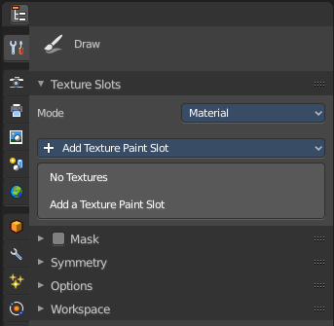
The Texture Paint Mode provides you the tools to paint directly at the texture of your mesh in the viewport. To fix visible seams for example.
The Texture Paint mode is just available for mesh objects.

Requirements
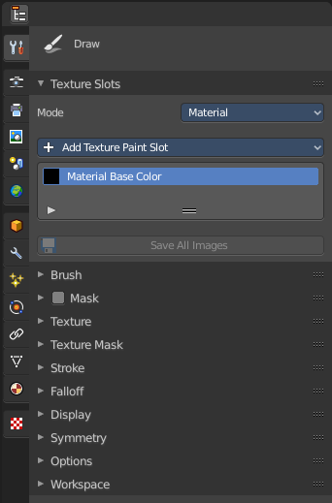
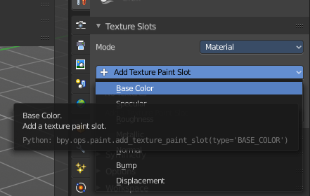
Texture Painting requires to have a working UV mapping and a texture applied. When there is no UV mapping and no assigned texture, then you will get a warning about No Texture. You have to create a texture slot first.

Open the Texture Paint Slot drop down menu, and choose Base Color. This will call a menu. Create a new blank texture.

Save Texture
The result of texture painting can be found and be saved in the UV Image Editor. You can also paint in the UV editor.
The modified texture does NOT save with the scene. You have to save out the image when you want to save the changes at the texture. There is no warning. So DON'T FORGET TO SAVE THE TEXTURE.
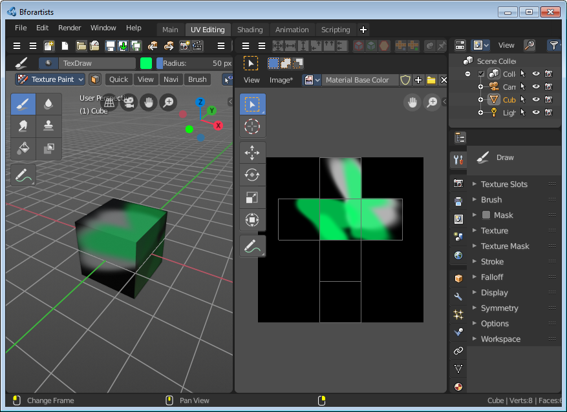

Brush Asset Panel
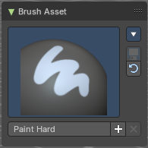
The Brush Asset Panel contains the different Brushes and some Brush settings. Choose and adjust your current active brush.

Browse Brush
The big image at the top is a dropdown box that allows you to choose a brush. Click at it, and you will see the different brushes. A click at one of the images will choose this brush then.
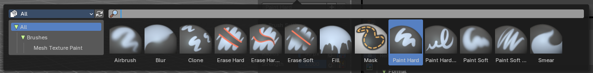
Brushes are assets. You can load them from different libraries if you want.

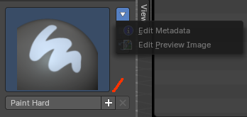
Brush Specials menu
This menu becomes active when you create a new brush. Which can be done wiht the Plus button in the name property. This data cannot be changed for builtin system brushes.

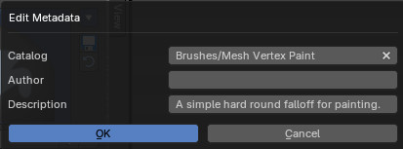
Edit Metadata
Calls a popup where you can adjust further informations and settings for the brush.

Catalog
The asset catalog in which the brush is stored.

Author
The brush author.

Desctription
Add a description

OK / Cancel
Accept or decline the changes.

Edit Preview Image
Allows you to load a custom preview image.

Save Brush Asset
This button is just active with a custom brush. It saves all changes made at the brush settings into the current custom brush.

Revert Brush Asset
Reverts the brush settings to the default values of the brush in the asset library.

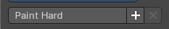
Name
The edit box below the Image shows the name of the current active brush.
The + button allows you to add a new pencil with the current settings. Note that the brushes are NOT automatically saved when you close Bforartists. You need to save the brush asset. See above.
The X button deletes the brush from the brushes list and from the asset library. This button is just active with a custom brush. You will be prompted by a warning so that you don't accidentally remove the brush.
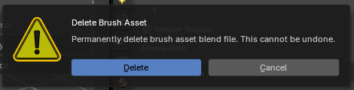

Brush settings Panel

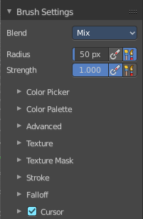
Brush Panel
The Brush Panel contains the different paint brushes, a color dialog, and some brush settings.

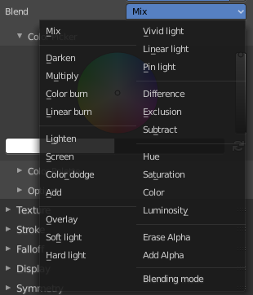
Blend
Define how the stroke will blend. You can choose between various blend modes.

Radius
The Radius edit box allows you to adjust the radius of the brush. The button behind the edit box enables tablet pressure sensitivity for radius.

Size Pressure
The first button behind the edit box enables tablet pressure sensitivity for radius.

Use Unified Radius
The second button behind the edit box enables global radius size. Any modification at the radius will also modify the radius value for other paint tools.

Strength
The Strength edit box allows you to adjust the strength of the brush. The button behind the edit box enables tablet pressure sensitivity for strength.

Size Pressure
The first button behind the edit box enables tablet pressure sensitivity for radius.

Use Unified Radius
The second button behind the edit box enables global radius size. Any modification at the radius will also modify the radius value for other paint tools.

Brush Settings Panel - Color Picker Sub panel
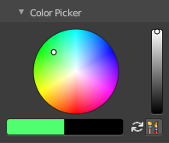
Define the color for your brush.
The active color is the left one. When you click the button with the two arrows down right then you can swap the color with the secondary color. Then this secondary color becomes the primary color, and is active.

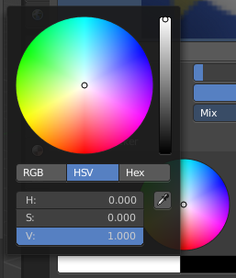
A click at one of the color fields will open a more detailed color dialog, where you can set up the color by using rgb, hsv and hex colors and with value sliders.

Brush colors flip
Flips the primary color with the secondary color.

Use unified Color
Choose if you want to use global colors or local color just for vertex painting.

Brush Settings Panel - Color Palette Sub panel

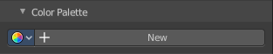
Create a color palette for later reuse.
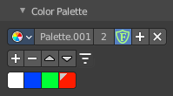
First create a new palette by clicking at New. Then adjust the color in the color picker. And then click at the add button to add this color to the palette.
To set the color picker to a palette color simply click at this palette color.
To remove a color from the palette, choose it, then click at the remove button. The active palette color that gets removed is the one with the triangle at it.
The color palette cannot be saved externally. It is part of the current blend file. You can however append color palettes from other blend files.
The elements are explained from left to right.

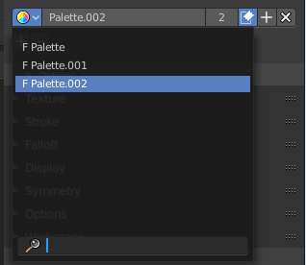
Palette browser
The button at the left opens a dropdown list where you can choose between your palettes.

Edit Box
The name of the currently active palette. You can also rename the palette here. A click into the edit box makes the name editable.

Number of users
See how many users the palette currently has.

Fake User
Fake User sets the element to have a fake user. Zero user data-blocks are normally not saved. But sometimes you want to force the data to be kept even when the data block has no user.

Add palette
Add a new palette.

Remove Palette
Clicking at this button removes the palette. Note that you need to save, close Bforartists and reload the blend file to remove the palette completely.

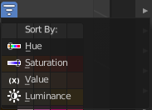
Sort By
Sort the palette by the chosen method.

Brush Settings Panel - Advanced Subpanel
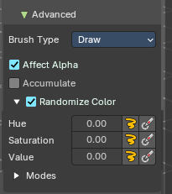
Brush specific settings.

Brush Type
Displays the current brush type (e.g., Draw, Blur, Average, Smear)

Accumulate
Accumulate stroke daubts on top of each other.

Affect Alpha
When disabled then the alpha is locked while painting.

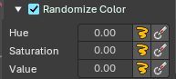
Randomize Color – Subpanel
Adds variation to the brush color per stroke or while drawing a stroke.

Slider Properties

Stroke Randomization
Use randomness per stroke, instead of while drawing a stroke. This will define a new random value when you draw a new stroke.

Use Pressure
Uses the brush pressure to define how random the influence will be. Maximum pressure is maximum randomization.

Hue
Shifts the base color across the color wheel.

Saturation
Adjusts the intensity of the color.

Value
Modifies the brightness of the stroke.

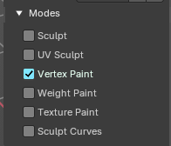
Modes – Subpanel
Allows to expose the brush in different modes sharing common attributes.
Example: You can make a brush for vertex mode and also texture paint mode.

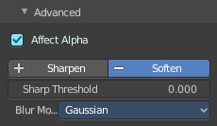
Sharpen / Soften (Soften Brush)

Sharp Threshold
The threshold below which no sharpening is performed.

Blur Mode (Soften Brush)
Choose the blur method. Gaussian or Box.

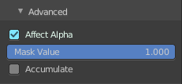
Mask Value (Mask brush)
The vertex weight when brush is applied.

Brush specific settings.

Brush Settings Panel - Texture Subpanel

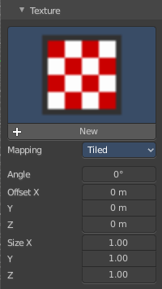
The Texture panel allows you to paint with textures. This allows you for example to grab a foto from some fish scales, and simply paint them onto the vertices by using this image as a pencil. Or as a blueprint where you calk through ( Stencil method ).

Browse Texture to be linked
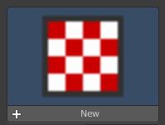
The image at the top of the panel is a image browser. Choose a texture that you can choose for vertex painting then. You can also have more than one image loaded at once.

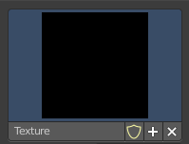
In this shot there is already a texture added. The way to add the texture here is a bit more complicated. And not done with clicking at the New button.
First click at the New button below the image. This will create a new texture slot. This slot is still empty, it displays black.

We need to load the texture in this slot. This must be done in the Properties editor in the Textures tab. And then the texture finally shows in the Texture panel in the Tool Shelf.
The problem is, we have an object with a material and a texture already selected. And when we change this texture , then we don't get the pencil texture loaded. But we change the texture at our mesh.

What we need to do is to create a material first. And in this material we load our pencil texture then. And then this texture becomes available in the image browser of the Texture panel.
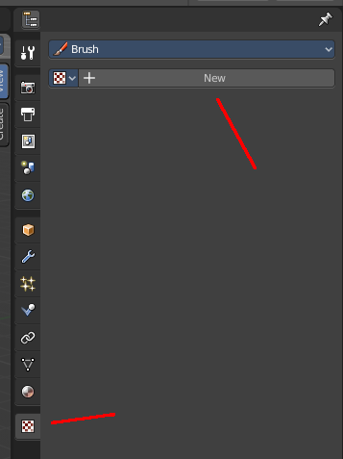
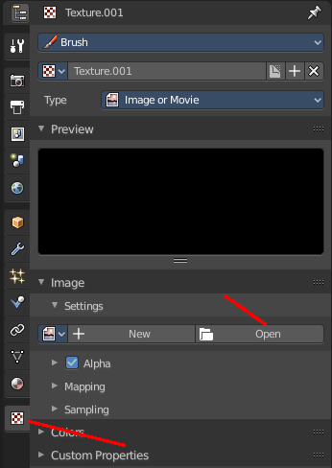
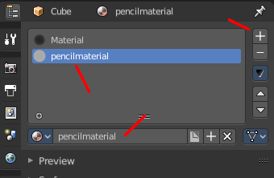
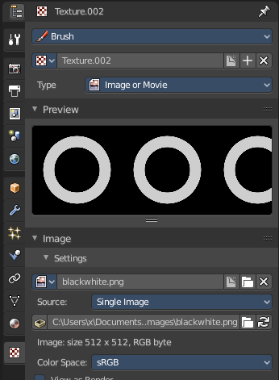
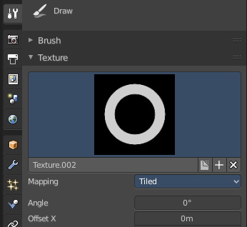
And when we switch back to the tools tab, then the texture is loaded. And we can work with this texture.

Texture Edit box
The Texture edit box is the edit box below the Image browser. When there's no image loaded then it displays the New button. When there's a image (or more) loaded, then you will see the name of the current texture.
The F button turns this texture into a data block with a fake user. Means it will exists even when there is no data connected to it anymore.
When you activate Fake User, then you may get a value in front of it, which displays how much users this data block (our texture slot) currently has.
The + Button adds another texture slot. Note that you will have to load a texture too, as explained above.
The X button deletes the texture slot.

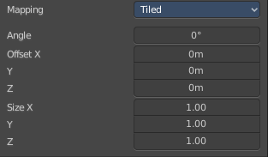
Brush Mapping
Our texture can be mapped in different methods. The Brush mapping is a dropdown box where you can choose this different brush mapping methods.
The settings vary. So we will go through them by the different brush mapping methods.

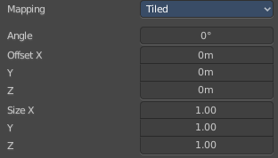
Brush Mapping with mapping method Tiled
The brush mapping method Tiled tiles the brush stroke at the surface. The mapping happens from the current view. The result may be distorted when the view does not align with the surface of the object.

Angle
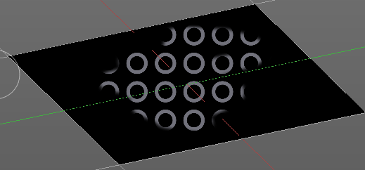
The angle of the brush.

Offset
The offset of the texture in the brush.

Size
The size of the texture in the brush.

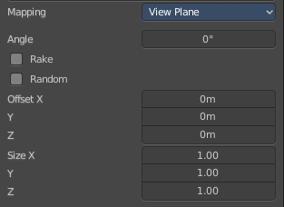
Brush Mapping with mapping method View Plane
The brush mapping method View Plane simply paints onto the surface. The mapping happens from the current view. The result may be distorted when the view does not align with the surface of the object.

Angle
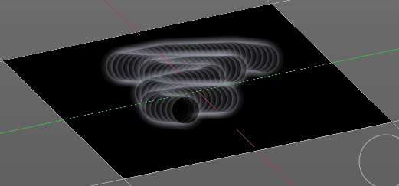
The angle of the brush.

Rake
The angle follows the direction of the brush stroke.

Random
The brush angle gets set random.

Offset
The offset of the texture in the brush.

Size
The size of the texture in the brush.

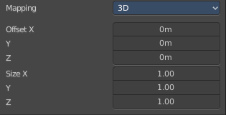
Brush Mapping with mapping method 3D
The brush mapping method 3D paints the texture at the surface, by tiling it 1/1 at the object surface.

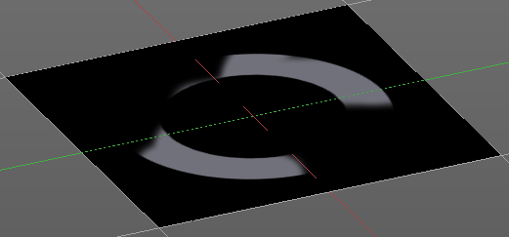
Offset
The offset of the texture in the brush.

Size
The size of the texture in the brush.

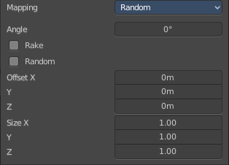
Brush Mapping with mapping method Random
The brush mapping method Random paints onto the surface, and randomizes the texture position in the brush while that. The mapping happens from the current view. The result may be distorted when the view does not align with the surface of the object.

Angle
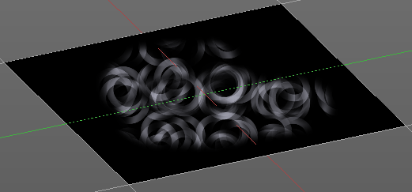
The angle of the brush.

Rake
The angle follows the direction of the brush stroke.

Random
The brush angle gets set random.

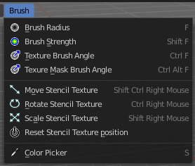
Brush Mapping with mapping method Stencil
The former methods uses the textures for the brush. The method Stencil works different. You have your texture displayed in the workspace above the object, and you paint this texture onto your object with your pencil strokes.
Note that the texture in the 3d space is just visible when you are with the mouse over the viewport.
It gets by default displayed down left. You have to position it where you need it. See Brush menu, Stencil Texture controls.
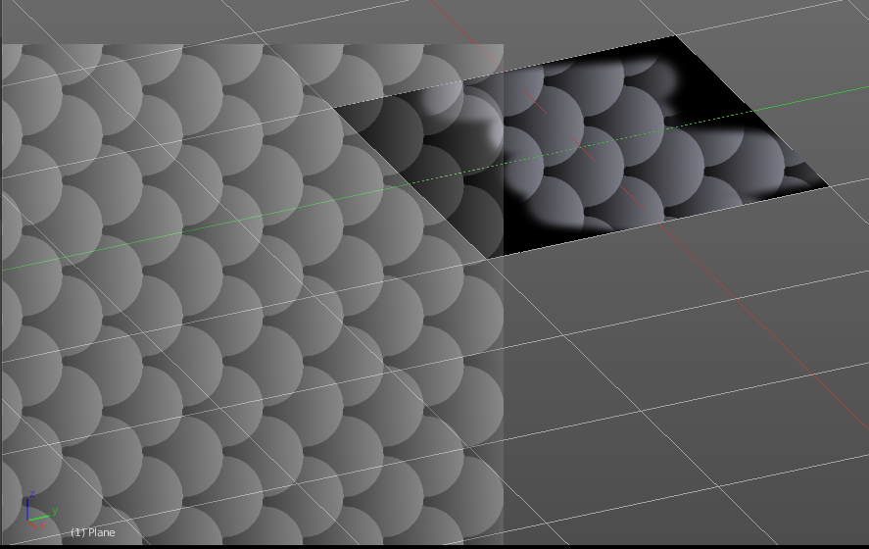
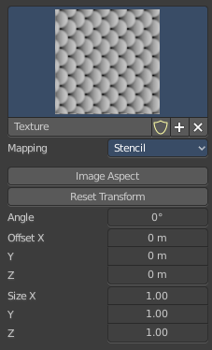

Image Aspect
Adjust the stencil size to fit to the image aspect ratio.

Reset Transform
Resets the stencil image to be down right in the 3D view.

Angle edit box
Adjust the angle of the brush. The button at the end allows you to set the radius by dragging the mouse. This should be done in the viewport and with the hotkey. This button is just a visible reminder.

Offset
Fine tune the offset of the texture in the brush.

Size
Fine tune the size of the texture in the brush.

Brush Settings Panel - Texture Mask Subanel

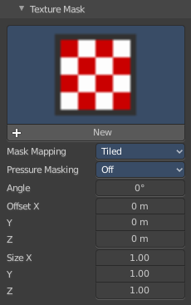
The texture mask subpanel allows you to use a texture as a mask to define the strength of painting. In the shot example we use a tiled fishscale Texture as a pencil, and a stencil map as our texture mask. And it paints just where the mask texture is bright. You can of course use gradients here to define the paint strength.

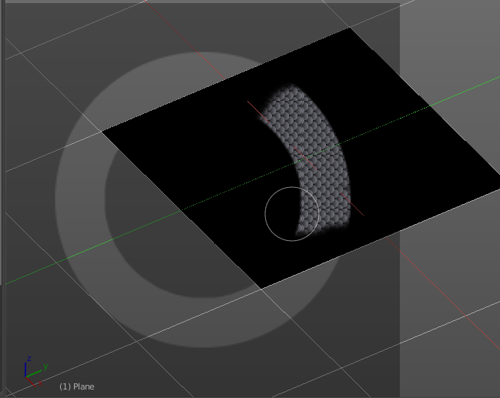

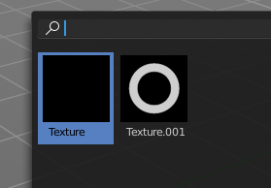
Browse Texture to be linked
The image at the top of the panel is a image browser. Choose a texture that you can choose for painting then. You can also have more than one image loaded at once.

In this shot there is already two textures added. The way to add the texture here is a bit more complicated. And not done with clicking at the New button.
First click at the New button below the image. This will create a new texture slot. This slot is still empty, it displays black.
We need to load a texture in this slot. This must be done in the Properties editor in the Textures tab.
The problem is, we have an object with a material and a texture already selected. And when we change this texture , then we don't get the pencil texture loaded. But we change the texture at our mesh.
What we need to do is to create a material first. And in this material we load our pencil texture then. And then we can choose this texture in the image browser of the texture.
And when we switch back to the tools tab, then the texture is loaded. And we can work with this texture.

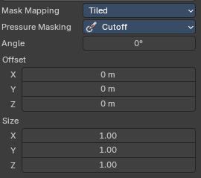
Brush Mapping with mapping method Tiled
The brush mapping method Tiled tiles the brush stroke at the surface. The mapping happens from the current view. The result may be distorted when the view does not align with the surface of the object.
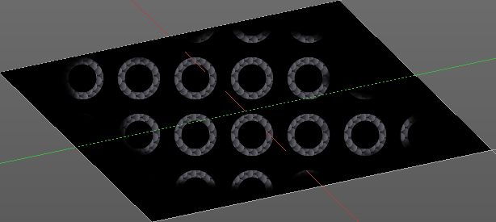

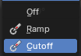
Pressure Masking
A dropdown box to choose the mask pressure mode for tablets.

Angle
The angle of the brush.

Offset
The offset of the texture in the brush.

Size
The size of the texture in the brush.

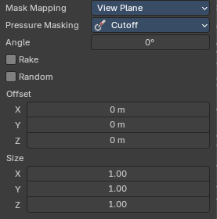
Brush Mapping with mapping method View Plane
The brush mapping method View Plane simply paints onto the surface. The mapping happens from the current view. The result may be distorted when the view does not align with the surface of the object.
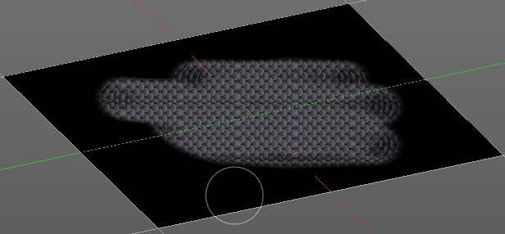

Pressure Masking
A dropdown box to choose the mask pressure mode for tablets.

Angle
The angle of the brush.

Rake
The angle follows the direction of the brush stroke.

Random
The brush angle gets set random.

Offset
The offset of the texture in the brush.

Size
The size of the texture in the brush.

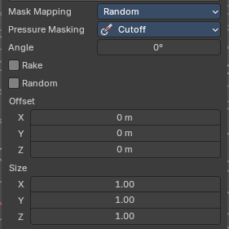
Brush Mapping with mapping method Random
The brush mapping method Random paints onto the surface, and randomizes the texture position in the brush while that. The mapping happens from the current view. The result may be distorted when the view does not align with the surface of the object.
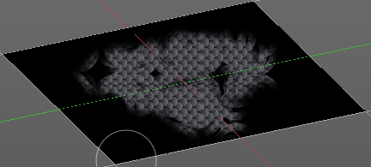

Pressure Masking
A dropdown box to choose the mask pressure mode for tablets.

Angle
The angle of the brush.

Rake
The angle follows the direction of the brush stroke.

Random
The brush angle gets set random.

Offset
The offset of the texture in the brush.

Size
The size of the texture in the brush.

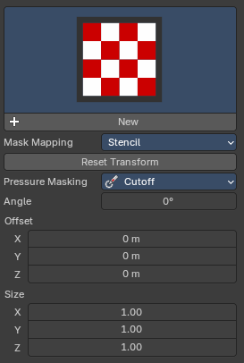
Brush Mapping with mapping method Stencil
The former methods uses the textures for the brush. The method Stencil works different. You have your texture displayed in the workspace above the object, and you paint this texture onto your object with your pencil strokes.

Note that the texture in the 3d space is just visible when you are with the mouse over the viewport. Note that the texture in the 3d space is just visible when you are with the mouse over the viewport. It gets by default displayed down left. You have to position it where you need it. See Brush menu, Stencil Texture controls.
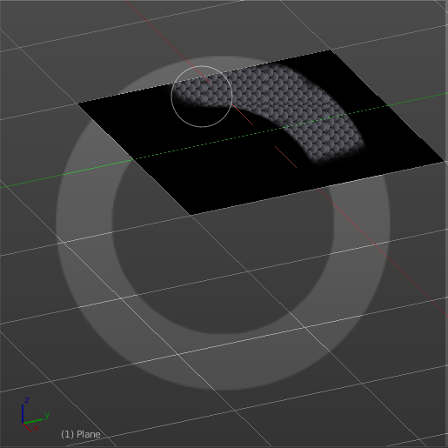
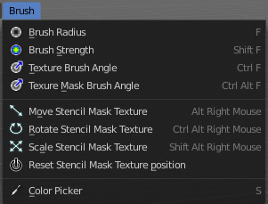

Reset Transform
Resets the stencil transformation to default.

Pressure Masking
A dropdown box to choose the mask pressure mode for tablets.

Angle edit box
Adjust the angle of the brush. The button at the end allows you to set the radius by dragging the mouse. This should be done in the viewport and with the hotkey. This button is just a visible reminder.

Offset
Fine tune the offset of the texture in the brush.

Size
Fine tune the size of the texture in the brush.

Brush Settings Panel - Stroke Sub panel

The Stroke panel contains settings to influence the behavior of the brush stroke. There are various stroke methods available. We will go through them one by one.

Stroke Panel with Stroke method Space
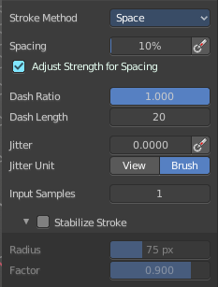
This is the default Stroke method. The sculpt stroke gets added continuously with given settings.
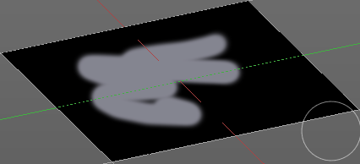

Spacing Edit Box
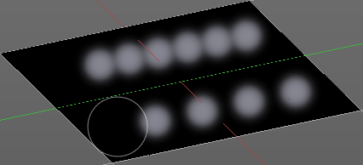
The sculpt drawing happens by mapping the pencil onto the mouse position. And when you move the mouse then the next mapping happens. Adjust the spacing after what mouse movement the next mapping should happen. The lower the value, the lower the distance between the single dots.

Spacing Pressure
The icon behind the edit box enables tablet pressure sensitivity for tablets.

Adjust Strength for Spacing
Automatically adjust strength to give consistent results for different spacing.

Dash Ratio
Ratio of samples in a cycle that the brush is covering.

Dash Length
Length of a dash cycle measured in stroke samples.

Jitter Edit Box
Add Jitter to the brush while painting.

Spacing Pressure
The icon behind the edit box enables tablet pressure sensitivity for tablets.

Jitter Unit
Jitter in screen space, or relative to the brush size.

Input Samples Edit Box
Average multiple input samples together to smooth the brush stroke.

Stabilize Stroke
The brush lags behind the mouse position, and produces a much smoother stroke by that.

Smooth Stroke Radius Edit Box
Is just active when Smooth Stroke is activated. Adjust the radius of the smoothing.

Smooth Stroke Factor Edit Box
Is just active when Smooth Stroke is activated. Adjust the factor of the smoothing.

Stroke Panel with Stroke method Curve
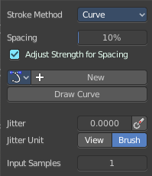
The Stroke method curve doesn't simply influence the way how the stroke is painted. It is a special method. First you draw a curve object by holding down ctrl and clicking with left mouse button. Then you tweak the curve. You can click at the curve point, and drag out handlers to make the curve points smooth.
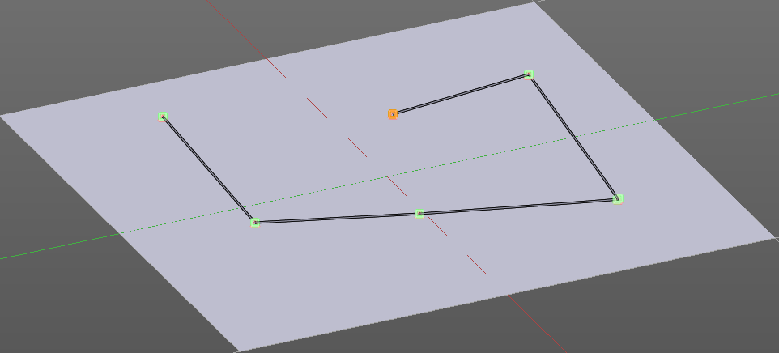
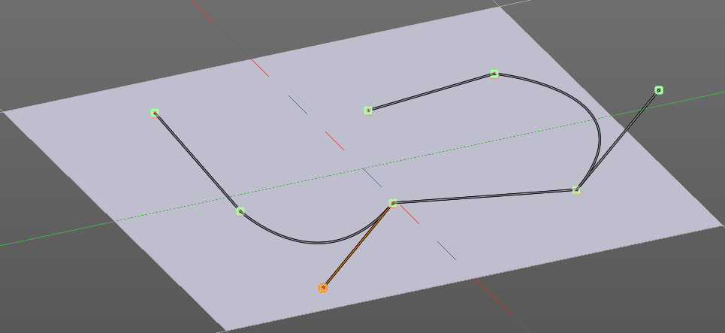
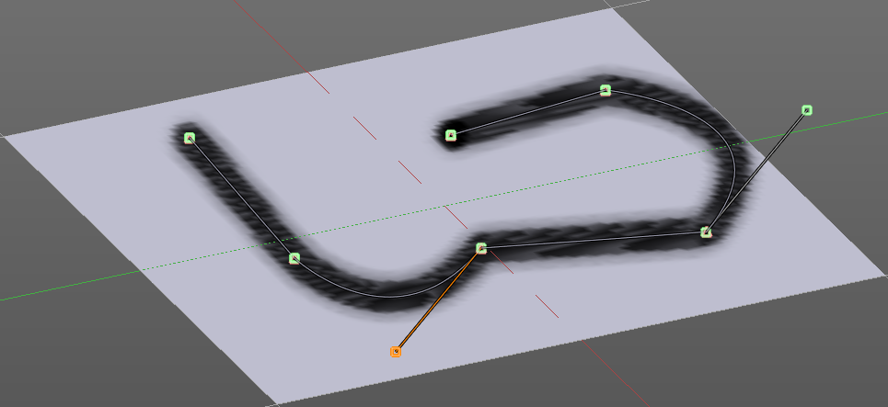
Then you hit the Draw Curve button. And the curve gets drawn onto the surface.

Spacing Edit Box
The drawing happens by mapping the pencil onto the mouse position. And when you move the mouse then the next mapping happens. Adjust the spacing after what mouse movement the next mapping should happen. The lower the value, the lower the distance between the single dots.
The icon behind the edit box enables tablet pressure sensitivity for tablets.

Adjust Strength for Spacing
Automatically adjust strength to give consistent results for different spacing.

Paint Curve edit box
Here you set the active curve.
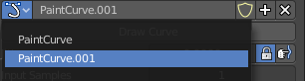
The first element is a drop down box where you will find your curves objects. You can have more than one.
The second element is the edit box that displays the active curve.
The number right of it, in this case 2, indicates how much number of users ( internally ) this brush uses. This means that this data block (the brush) shares currently settings with at least one other object. Most probably the parent brush where we have created it from. Click at the value to make this brush a single user. The button will vanish then.
F set the brush to have a fake user. Zero user data-blocks are normally not saved. But sometimes you want to force the data to be kept even when the data block has no user.
The + button allows you to add a new pencil with the current settings. Note that the brushes are NOT saved when you close Bforartists. You can save them into the current blend file. Or you can save the startup file. But be careful here. This saves everything else of the current state of Bforartists too.
The X button deletes the brush as the active one. It does NOT delete it from the brushes list.

Draw Curve Button
A click at it to turns the curve into a sculpt stroke.

Jitter Edit Box
Add Jitter to the brush while painting.

Jitter Pressure
The icon behind the edit box enables tablet pressure sensitivity for tablets.

Jitter Unit
Jitter in screen space, or relative to the brush size.

Input Samples Edit Box
Average multiple input samples together to smooth the brush stroke.

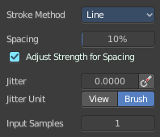
Stroke Panel with Stroke method Line
With Stroke method line you draw a line between a starting point and an endpoint. And when you release the mouse then the line gets sculpted.

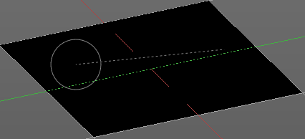
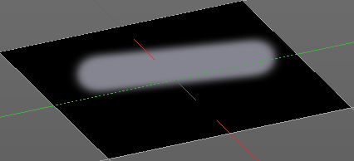

Spacing Edit Box
The drawing happens by mapping the pencil onto the mouse position. And when you move the mouse then the next mapping happens. Adjust the spacing after what mouse movement the next mapping should happen. The lower the value, the lower the distance between the single dots.
The icon behind the edit box enables tablet pressure sensitivity for tablets.

Adjust Strength for Spacing
Automatically adjust strength to give consistent results for different spacing.

Jitter Edit Box
Add Jitter to the brush while painting.

Jitter Pressure
The icon behind the edit box enables tablet pressure sensitivity for tablets.

Jitter Unit
Jitter in screen space, or relative to the brush size.

Input Samples Edit Box
Average multiple input samples together to smooth the brush stroke.

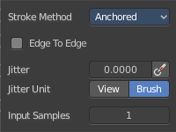
Stroke Panel with Stroke method Anchored
Click and drag to place a dot and to scale it.

Edge to edge
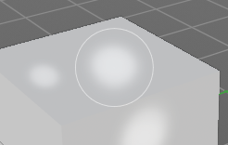
Drag Anchor Brush from edge to edge.

Jitter Edit Box
Add Jitter to the brush while painting.

Jitter Pressure
The icon behind the edit box enables tablet pressure sensitivity for tablets.

Jitter Unit
Jitter in screen space, or relative to the brush size.

Input Sample Edit Box
Average multiple input samples together to smooth the brush stroke.

Stroke Panel with Stroke method Airbrush
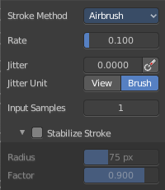
The stroke acts like an airbrush pencil. The dots gets placed randomly.
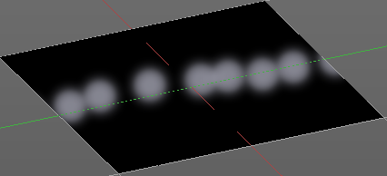

Rate Edit Box
Define the rate of the drawing.

Jitter Edit Box
Add Jitter to the brush while painting.

Jitter Pressure
The icon behind the edit box enables tablet pressure sensitivity for tablets.

Jitter Unit
Jitter in screen space, or relative to the brush size.

Input Samples Edit Box
Average multiple input samples together to smooth the brush stroke.

Stabilize Stroke
The brush lags behind the mouse position, and produces a much smoother stroke by that.

Smooth Stroke Radius Edit Box
Is just active when Smooth Stroke is activated. Adjust the radius of the smoothing.

Smooth Stroke Factor Edit Box
Is just active when Smooth Stroke is activated. Adjust the factor of the smoothing.

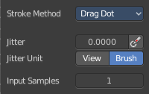
Stroke Panel with Stroke method Drag Dot
Paint a dot and drag it around. The actual painting happens then at releasing the mouse

Jitter Edit Box
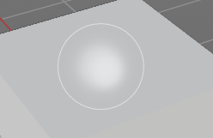
Add Jitter to the brush while painting.

Jitter Pressure
The icon behind the edit box enables tablet pressure sensitivity for tablets.

Jitter Unit
Jitter in screen space, or relative to the brush size.

Input Samples Edit Box
Average multiple input samples together to smooth the brush stroke.

Stroke Panel with Stroke method Dots
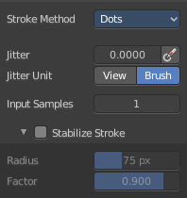
The stroke method Dots draws dots of the pencil onto the surface. The mapping happens from the current view. Means you will get distortions when your view is not aligned with the surface of the object.

Jitter Edit Box
Add Jitter to the brush while painting.

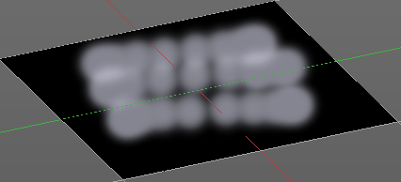
Jitter Pressure
The icon behind the edit box enables tablet pressure sensitivity for tablets.

Jitter Unit
Jitter in screen space, or relative to the brush size.

Input Samples Edit Box
Average multiple input samples together to smooth the brush stroke.

Stabilize Stroke
The brush lags behind the mouse position, and produces a much smoother stroke by that.

Smooth Stroke Radius Edit Box
Is just active when Smooth Stroke is activated. Adjust the radius of the smoothing.

Smooth Stroke Factor Edit Box
Is just active when Smooth Stroke is activated. Adjust the factor of the smoothing.

Brush Settings Panel - Falloff Sub panel
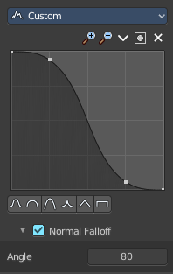
The curve panel allows you to define different falloffs methods for the border of the brush.


Selecting Points
You can select curve points. This reveals two edit boxes for the x and y coordinate of this point.
Selected points can be moved around. Left click at them, hold the mouse button down and move them to a new location.


Adding Points
You can add new curve points by simply left clicking at the curve. Move the mouse to position them where you need it.

Navigation elements
The navigation elements at the top are described from left to right.

Zoom in and out
The two buttons with the magnifying glass at it zooms in and out in the curve window.

Tools
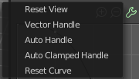
Tools is a menu where you can find some curve related tools.

Reset View
Resets the curve windows zoom.

Vector Handle
Set handle type to Vector.

Auto Handle
Set handle type to Auto.

Auto Clamped Handle
Set handle type to Auto Clamped.

Reset Curve
Resets the curve to the initial shape.


Use Clipping
Clipping options. Set up clipping for the stroke.

Delete Points
Deletes selected curve points.

Curve window
Tweak and adjust the falloff curve by clicking at a curve point and dragging it around.
Double click adds a new point.
Holding down ctrl activates temporary snapping.
Holding down shift enables slower movement, which allows more accurate setting.


Curve Presets
Predefined curve presets.

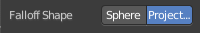
Falloff Shape
Use projected or spherical falloff.

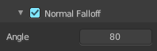
Normal Falloff
Blend Brush influence, dependent by how much they face the front.

Angle
Adjust the angle.

Brush Settings Panel - Cursor Sub panel

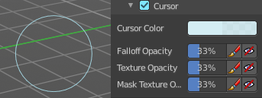
Adjust the color and appearance of the brush cursor to custom values.

Cursor Checkbox
Activate the custom settings.

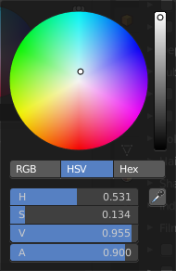
Cursor Color
Choose another color for the brush cursor. Double clicking at the color field will open a color picker.

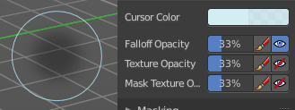
Falloff Opacity
You can turn on the cursor overlay with the eye button at the end. The falloff opacity slider allows you to adjust the opacity of this cursor overlay.

Override Overlay
Hide the Cursor Overlay when painting.

Use Cursor Overlay
Turn on Cursor Overlay.

Texture Opacity
This is for the case when you paint with a texture brush. You can turn on the Texture overlay with the eye button at the end. The falloff opacity slider allows you to adjust the opacity of this cursor overlay.

Override Overlay
Hide the Texture Overlay when painting.

Use Cursor Overlay
Turn on Texture Overlay.

Mask Texture Opacity
This is for the case when you mask paint with a texture brush. You can turn on the Texture overlay with the eye button at the end. The falloff opacity slider allows you to adjust the opacity of this cursor overlay.

Override Overlay
Hide the Texture Overlay when painting.

Use Cursor Overlay
Turn on Texture Overlay.

Brush Settings Panel - Clone from Paint Slot Sub panel

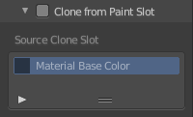
This panel is just for the clone tool in the tool shelf.

Activate to clone from the current texture. For the clone tool description see tool shelf. Here you just can activate, then see or choose the material to clone from. It is a list.

Symmetry Panel

Symmetry Panel
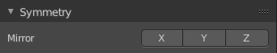
Turn on/off symmetry painting along X, Y and Z axis. The mirroring happens along the world axis.
The same buttons can also be found in the tool settings bar as icon buttons. This allows quicker access and better visual control which mirror axis is currently active.
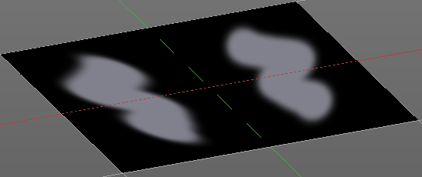

Options Panel
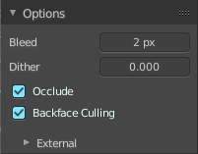

Bleed
An edit box to adjust the amount of bleeding into the areas outside of the faces UV.

Dither
An Edit box to adjust the amount of dither when painting on byte images

Occlude
Only paint the faces directly under the mouse.

Backface Culling
Ignore faces that are painting away from the viewport.

External
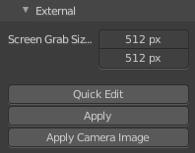
The external sub panel allows you to do projection painting by using an external 2d image editor. The projection happens from the current view. So this can lead to distortions.

Screen Grab Size
Set the resolution of the shot.

Quick Edit
Opens a shot of the current view in your 2D Image Editor.

Apply
Applies the changes that you made and saved in your 2D Image Editor.

Apply Camera Image
Project an edited render from the active camera back onto the object.
This feature requires to have a background image loaded. Then this background image can be projected onto the object from the camera view.

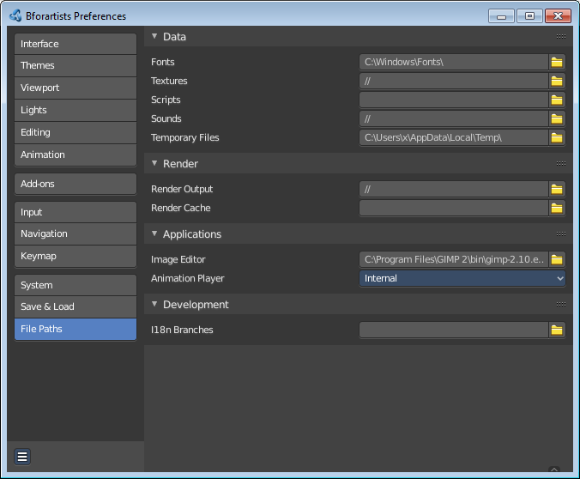
Workflow for external editing

Preparations
You first have to link your software that you want to use here. When there is no image editor linked then you will get a warning.
Open the User Preferences, go to the File tab. Here choose the Image Editor section, and browse for your image editor. I have chosen Gimp here at Windows 7.

Don't forget to save the User Settings!

For further options have a look in the Project Paint panel.

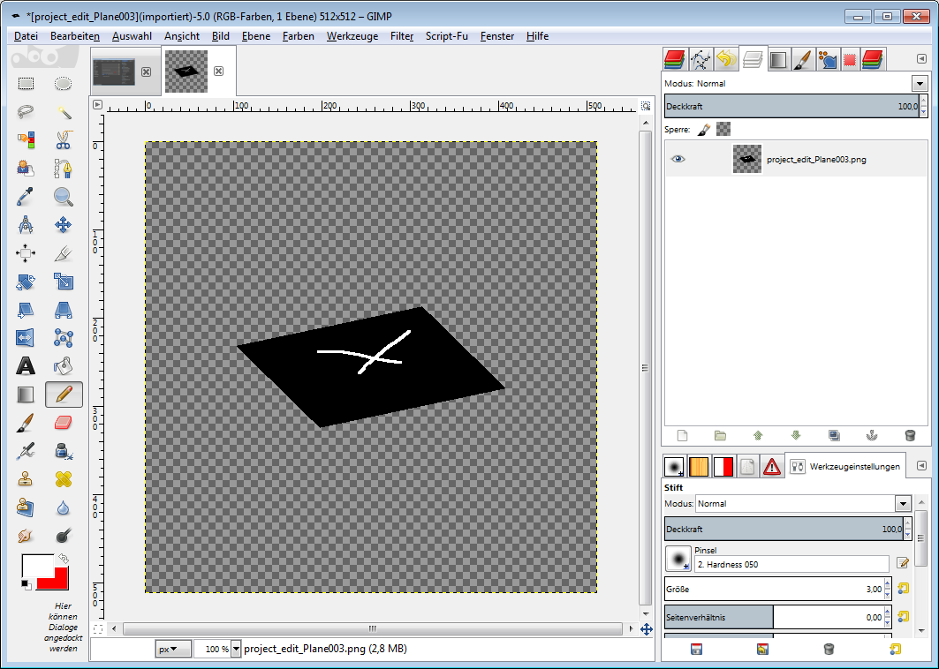
Usage

Click at the Quick Edit Button. And your image editor will open up with a shot from the current view. Modify your image.

When done simply overwrite the image. Sorry for the german shot ...

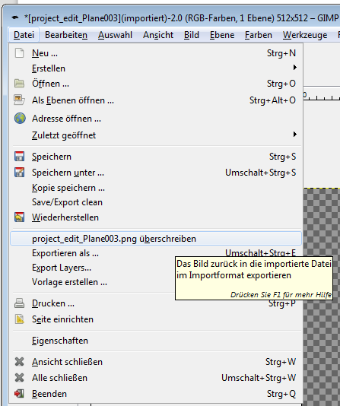
Back in Bforartists click at the Apply button. And the result gets mapped onto your object.

Attention, don't change the camera view while doing this. Mapping happens from the current camera view!

